**Lab Guide**

IBM Business Automation Manager Open Edition

Nigel Crowther – ncrowther@uk.ibm.com

Hands-on Lab

Integrating Watsonx Orchestrate with Open-Source Solutions

V1.0

01-Jan-2024



NOTICES

This information was developed for products and services offered in the USA.

IBM may not offer the products, services, or features discussed in this document in other countries. Consult your local IBM representative for information on the products and services currently available in your area. Any reference to an IBM product, program, or service is not intended to state or imply that only that IBM product, program, or service may be used. Any functionally equivalent product, program, or service that does not infringe any IBM intellectual property right may be used instead. However, it is the user's responsibility to evaluate and verify the operation of any non-IBM product, program, or service.

IBM may have patents or pending patent applications covering subject matter described in this document. The furnishing of this document does not grant you any license to these patents. You can send license inquiries, in writing, to:

IBM Director of Licensing

IBM Corporation

North Castle Drive, MD-NC119

Armonk, NY 10504-1785

United States of America

The following paragraph does not apply to the United Kingdom or any other country where such provisions are inconsistent with local law: INTERNATIONAL BUSINESS MACHINES CORPORATION PROVIDES THIS PUBLICATION "AS IS" WITHOUT WARRANTY OF ANY KIND, EITHER EXPRESS OR IMPLIED, INCLUDING, BUT NOT LIMITED TO, THE IMPLIED WARRANTIES OF NON-INFRINGEMENT, MERCHANTABILITY OR FITNESS FOR A PARTICULAR PURPOSE. Some states do not allow disclaimer of express or implied warranties in certain transactions, therefore, this statement may not apply to you.

This information could include technical inaccuracies or typographical errors. Changes are periodically made to the information herein; these changes will be incorporated in new editions of the publication. IBM may make improvements and/or changes in the product(s) and/or the program(s) described in this publication at any time without notice.

Any references in this information to non-IBM websites are provided for convenience only and do not in any manner serve as an endorsement of those websites. The materials at those websites are not part of the materials for this IBM product and use of those websites is at your own risk.

IBM may use or distribute any of the information you supply in any way it believes appropriate without incurring any obligation to you.

Information concerning non-IBM products was obtained from the suppliers of those products, their published announcements or other publicly available sources. IBM has not tested those products and cannot confirm the accuracy of performance, compatibility or any other claims related to non-IBM products. Questions on the capabilities of non-IBM products should be addressed to the suppliers of those products.

This information contains examples of data and reports used in daily business operations. To illustrate them as completely as possible, the examples include the names of individuals, companies, brands, and products. All of these names are fictitious and any similarity to the names and addresses used by an actual business enterprise is entirely coincidental.

**TRADEMARKS**

IBM, the IBM logo, and ibm.com are trademarks or registered trademarks of International Business Machines Corp., registered in many jurisdictions worldwide. Other product and service names might be trademarks of IBM or other companies. A current list of IBM trademarks is available on the web at “Copyright and trademark information” at www.ibm.com/legal/copytrade.shtml.

Adobe, the Adobe logo, PostScript, and the PostScript logo are either registered trademarks or trademarks of Adobe Systems Incorporated in the United States, and/or other countries.

Cell Broadband Engine is a trademark of Sony Computer Entertainment, Inc. in the United States, other countries, or both and is used under license therefrom.

Intel, Intel logo, Intel Inside, Intel Inside logo, Intel Centrino, Intel Centrino logo, Celeron, Intel Xeon, Intel SpeedStep, Itanium, and Pentium are trademarks or registered trademarks of Intel Corporation or its subsidiaries in the United States and other countries.

IT Infrastructure Library is a Registered Trade Mark of AXELOS Limited.

ITIL is a Registered Trade Mark of AXELOS Limited.

Java and all Java-based trademarks and logos are trademarks or registered trademarks of Oracle and/or its affiliates.

Linear Tape-Open, LTO, the LTO Logo, Ultrium, and the Ultrium logo are trademarks of HP, IBM Corp. and Quantum in the U.S. and other countries.

Linux is a registered trademark of Linus Torvalds in the United States, other countries, or both.

Microsoft, Windows, Windows NT, and the Windows logo are trademarks of Microsoft Corporation in the United States, other countries, or both.

UNIX is a registered trademark of The Open Group in the United States and other countries.

© Copyright International Business Machines Corporation 2020.

This document may not be reproduced in whole or in part without the prior written permission of IBM.

US Government Users Restricted Rights - Use, duplication or disclosure restricted by GSA ADP Schedule Contract with IBM Corp.

**Table of Contents**

0. Introduction 4

0.1 Pre-requisites 4

1. Build a decision service to calculate speeding fines 5

1.1 Before you start 6

1.2 Run the Decision Service 10

1.3 Expose the decision service 11

1.4 Test the Decision Service 12

2. Generate an OpenAPI specification 14

3. Import the OpenAPI into watsonx Orchestrate 18

4. Persist Decisions 21

5. Create a Composite Flow using Decisions, Cloudant and React 25

6. Conclusion 33

7. Advanced Labs 34

8. Advanced Lab 1 35

9. Advanced Lab 2 – Create a Cloudant Speeding Ticket Service 37

9.1 Local host Prerequisites 37

9.2 Run on local host 37

9.3 Code Engine Hosting Prerequisites 39

9.4 Deployment to Code Engine 40

10. Advanced Lab 3 – Create a Report in React 42

10.1 Run on local host 42

10.2 Deployment to Code Engine 42

# Introduction

In this Lab you connect watsonX Orchestrate using open-source solutions

A short video introduction of the use case for this lab is here:

<https://youtu.be/JxjfAQh8ii0>

The three open-source solutions used in the demo are:

* **BAMOE** – to run the decision service.

See <https://www.ibm.com/products/business-automation-manager-open-editions>

* **Cloudant** – to store ticket data.

See https://www.ibm.com/products/cloudant

* **React** –to create the ticket report.

See <https://react.dev/>

The Lab is structured into the following sections.

* Build a speeding ticket decision service.
* Build a skill to save the ticket to a database.
* Build a skill flow to combine the above and create a report.

## Pre-requisites

To perform this Lab, you need:

* Microsoft Remote Desktop (RDP)
* A GitHub Account. See https://github.com
* An IBM watsonx Orchestrate Standard account with Builder role.
* Techzone BAMOE VM

Alternatively, you can build a local laptop environment, in which case you need:

* VSC and the IBM BAMOE plugin
* Git Bash
* Latest Java JDK

# Build a decision service to calculate speeding fines

In this task, you ...

* Import a speeding ticket decision service.
* Run the service locally.
* Expose the decision service to the outside world

## Before you start

In this exercise, you will build and test the decision service using Visual Studio Code (VSC).

1. Find the following BAMOE Techzone image (or later version if available):

<https://techzone.ibm.com/collection/ibm-business-automation-manager-open-editions-environment/environments>

**IMPORTANT!** When reserving, ensure VPN access is enabled. This is essential for the lab to work:

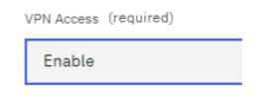

2. Once the VM is reserved, login with Remote Desktop (RDP). On Windows this is:

**User:** .\techzone

**Password:** IBMDem0s!

For further details see the guide here: <https://ibm.box.com/v/IBM-BAMOE-ENV>

1. Open Git Bash by clicking the Git Bash  icon on the Windows **Taskbar** at the bottom of the screen.
2. Within the Git Bash shell, clone the rule project using the command:

git clone <https://github.com/ncrowther/bamoe2wxo>

1. Hit return. You should see the git repository cloned into the local drive:

Open the decision project with VSC:

cd bamoe2wxo/

code SpeedingDecisionService/

1. VSC will open:

1. **IMPORTANT**: If you are using the Techzone VM you must update VSC to version 1.85 or later. Select *Help->Check for Updates...* Then restart VSC with the latest version.
2. On the left-hand side of Visual Studio Code in file explorer locate *src\main\resources\TrafficViolation.dmn*A screenshot of a computer

   Description automatically generated
3. Click the DMN file to view it:

1. On the far right, select the properties icon . In the *DMN Model Name,* prepend the name with your initials. For example, if your initials are XXX, the *DMN Model name* would be *XXXTrafficViolation*:

1. Select the *Fine* decision and edit it by selecting 

1. You should see the decision table below:

This decision table will be used later in the lab to calculate speeding fines depending on severity.

1. Press Save (Ctl S).

## Run the Decision Service

In this step we are going to run our decision service in development mode using Quarkus. For details on Quarkus, visit <https://quarkus.io/>

1. Within the VSC editor, click on the **Terminal** menu at the top of the screen:



1. In the drop down click on **New Terminal**.

1. In this terminal window, verify you are in the *SpeedingDecisionService* folder and then run Mavern build:

mvn quarkus:dev

**Tip**: You can enlarge the terminal window by dragging up the top edge.

1. Once built, our decision model is deployed locally and ready to run. Take note of the URL encircled below. This is the development URL:

## Expose the decision service to the internet!

1. Within the VSC editor, click the PORTS tab:

1. Select *Forward a Port* .
2. Enter port *8123* and hit return. After a few seconds, you may see the following:

1. Select *Allow* and enter your GitHub credentials.
2. If successful, you should be returned to VSC and see this:

1. Right-click *Private* in the *Visibility* column and change *Port Visibility* from *Private* to *Public*:

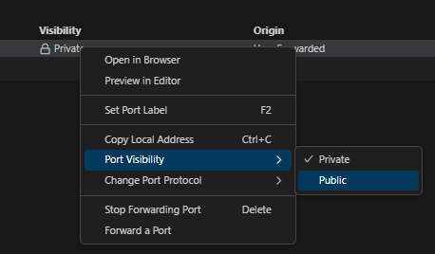

1. Press *Continue* to accept the warning message. Select the *copy local address* button  and then store the exposed URL into notepad (or equivalent) for later use.



## Test the Decision Service

Let’s look at the API generated by Quarkus.

1. Open a browser on the VM.
2. Paste the following URL into the browser address and press **Enter**.

<http://localhost:8123/q/swagger-ui/>

1. You should see this:  
   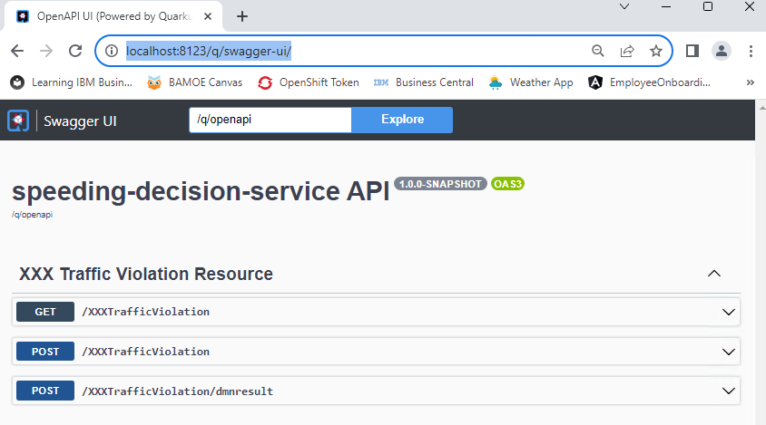

You are looking at the decision service endpoints. If the instructions were followed, your endpoints will have your initials prepended rather than XXX. You should see three endpoints, but the only endpoint we are interested in is **POST /TrafficViolation**.

1. Click on the **POST /TrafficViolation** endpoint to expand it, then click the **Try it out** button on the right-side.  
   A white rectangular object with a black border

   Description automatically generated
2. Enter data into the request body:

{

"Violation": {

"Date": "2023-12-21",

"SpeedLimit": 20,

"ActualSpeed": 40

},

"DriverId": "D45454"

}

1. Press *Execute*. You should see the following in the server response:

**Response Body**

**{**

**"Violation": {**

**"SpeedLimit": 20,**

**"ActualSpeed": 40,**

**"Date": "2023-12-21"**

**},**

**"DriverId": "D45454",**

**"Fine": {**

**"Points": 3,**

**"Amount": 500**

**}**

1. Verify the points are 3 and the fine is 500.
2. Congratulations, you have built and deployed the Speeding Ticket decision service on your local machine and exposed it via port forwarding. The next step is to generate an OpenAPI specification to execute the service from watsonx Orchestrate.

# Generate an OpenAPI specification

In this section you generate an OpenAPI specification for watsonx Orchestrate.

**Important!** You must create a new VSC session. The decision service in the previous section must still be running in a separate VSC session.

1. Reopen Git Bash shell
2. Within the Git Bash shell, open the *OpenApiGenerator* folder in VSC:

cd ~/bamoe2wxo

code OpenApiGenerator/

1. The VSC editor appears.

1. Expand the /*data* folder and edit *config.json*. You should see this:

1. Change the name of *decisionId* by replacing [YOUR_INITIALS] with your initials. This should be the same name as in section 7. For example, if your initials are XXX, the DMN Model name would be XXXTrafficViolation.
2. Change *localUrl* to the local URL of your running Kogito service. If you are using the Techzone VM this should be already correct.
3. Change the external URL to the one defined on page 11.
4. Double check your changes are correct then save *config.json* using Ctrl-S
5. Open *CreateOpenApi.java* in the /*src/converter* folder:

1. Right-click anywhere in the code and select *Run Java*. Accept the Windows Defender message if it appears. You should see this:

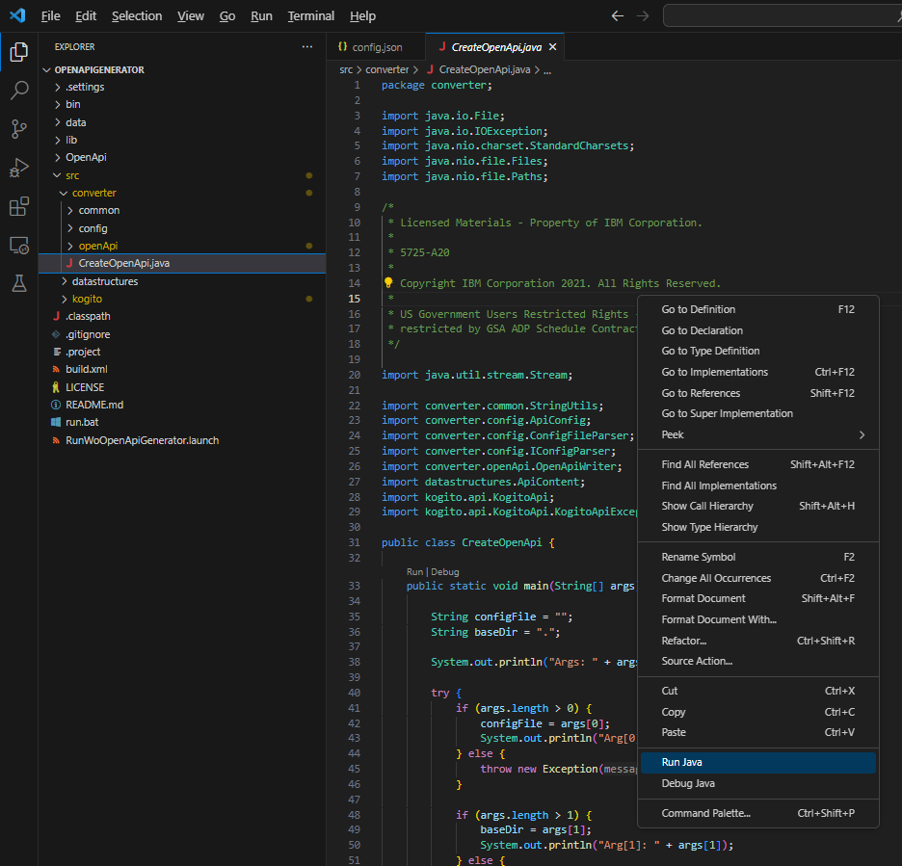

1. An open API file is generated. The generation is logged in the terminal of VSC:

If you see an error instead, check that your decision service is still running from section 1.2

1. Within VSC, open

\generated\[YOUR_INITIALS]TrafficViolation.json

1. Copy and paste (Ctrl-A, Ctrl-C, Ctrl-V) the entire file contents into <https://editor.swagger.io>
2. Press OK when you see the convert to YAML message:

1. You should see the same decision service we inspected in section 1.4

1. But there are differences compared with the original:

* Your initials have been appended.
* *x-ibm* annotations have been added.
* The data model has been pulled into the specification.
* Only one endpoint is generated.

1. Test the OpenAPI following the steps specified in section 1.4

The OpenAPI is now ready to be imported into watsonx Orchestrate!

# Import the OpenAPI into watsonx Orchestrate

1. Login to **IBM watsonx Orchestrate:** <https://dl.watson-orchestrate.ibm.com>
2. Under build skills, select *add skills*
3. Select *From files*
4. Drag the OpenAPi file below into the drop area:

*~/bamoe2wxo/OpenApiGenerator/generated\[YOUR_INITIALS]TrafficViolation.json*

**TIP:** If you are using the TechZone VM you need to perform this in two steps

* 1. Copy the remote file to your local desktop
  2. Drag the local file to the drop area

1. Click Next. Select the *[YOUR_INITIALS]TrafficViolation* skill and press *Add*.

1. In , type in your [YOUR_INITIALS]*TrafficViolation* skill.
2. On the far right, click the button with three vertical dots, and select *Enhance this skill*:

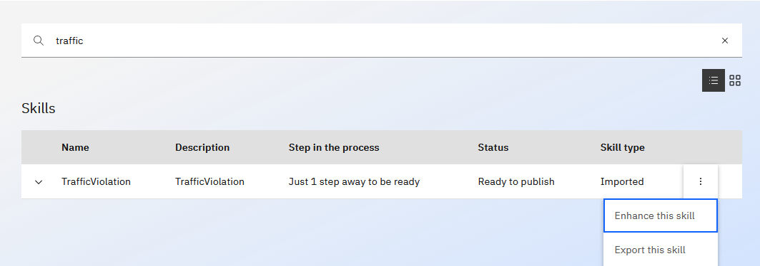

1. Publish the skill:

1. Click on *Skills Catalog*
2. In the *Find a skill* text field, search for [YOUR_INITIALS]*TrafficViolation* skill (type in the full name to find it). Select it and press *Add skill*

1. At the top right, click on Connect app  and enter any username and password (credentials are placebos).
2. Go to *Chat* (Personal Skills) and run the skill by typing *[YOUR_INITIALS]trafficviolation*
3. The Traffic Violation data form appears. Enter the following data:

1. Hit *Apply*. This invokes the decision service you created in the previous steps.
2. The response should be:

Congratulations! You have run your first BAMOE Decision Service from watsonx Orchestrate.

# Persist Decisions

In this section we call a database to store speeding tickets. We use a public instance. If you are interested in creating your own private instance, follow section 5.

1. Back in your TechZone VM, reopen Git Bash shell
2. Within the Git Bash shell, open the *cloudantFacade* in VSC. You should leave the other two VSC instances open.

cd ~/bamoe2wxo

code cloudantFacade/dataservice

1. The VSC editor should appear with the *cloudantFacade/Dataservice* folder.
2. **IMPORTANT:** Do NOT close the other VSC instances as you still need them.

1. Expand the *openapi* folder and edit *dataApi.yaml*
2. Perform a global search and replace of the text [YOUR_INITIALS], replacing with your initials. To do this, select Ctrl-R:

1. Save *dataApi.yaml* (Ctrl-S)
2. Paste the contents of *dataApi.yaml* into <https://editor.swagger.io>
3. You should see the following (with your initials instead of XXX):

1. Now we will import this API into watsonx Orchestrate
2. Login to IBM watsonx Orchestrate
3. Under *Build* *skills*, select *add skills* from *Files* then drag and drop the *dataApi.yaml* API spec:

1. Click Next. Select the first twoskills and press *Add*.

1. Publish both skills and add them to your catalog, as described in section 3
2. You should now have both skills published under the *cloudantWxoFacade* and added to your catalog.
3. Go to Chat (Personal Skills). Run the skill *write a doc to cloudant.* Enter a *driverId* starting with D and then six numbers, and a date following the format YYYY-MM-DD. Any other values are fine:

1. Hit Apply.
2. Now run the *get docs from cloudant* skill. You should see all speeding fines retrieved from the database.
3. Find your entry by using the search  button:

Congratulations! You have run your first Cloudant skill by entering and retrieving data using watsonx Orchestrate.

# Create a Composite Flow using Decisions, Cloudant and React

We will now combine the Decision skill and the Cloudant skill with a React UI.

1. Under *Build* *Skills*, select the down arrow on the *Add Skills* button and choose *Create a skill flow*.

1. You should see the following:

1. Select the pen  and name the flow *[YOUR_INITIALS]* *IssueSpeedingTicket*, where [YOUR_INITIALS] are your initials.
2. Press Save.
3. Select the  symbol and add *[YOUR_INITIALS]TrafficViolation*. The search requires the full name. Your flow should look like this (where NTC should be your initials):

1. Select the rightmost  symbol and add *[YOUR_INITIALS]write a doc to Cloudant*. Your flow should look like this:

1. Select *write a doc to Cloudant*.
2. Select *generate mapping suggestions*.
3. Slide the toggle *Hide this form from the user*. You should see this:

1. At the very bottom of the form, enter *Speeding* as the *offenceType*:

1. Select the rightmost  symbol and add *[YOUR_INITIALS]get docs from Cloudant*. Your flow should look like this:

1. Select the rightmost  symbol and add *Custom Forms->Input Form*
2. Slide the toggle *Hide this form from the user*. You should see this:

1. Press *the Add input field* button and assign it a type of *Single line text*:

1. Press *Next* and give it a label of *TicketURL.* Press Apply. You should see this:

1. Select *TicketURL* and map it to *driverId* from *get docs from Cloudant.*

**Important!** This must be *driverId* from *get docs from Cloudant* and **not** *write a doc to cloudant*

1. In the *Define Transformations* section, enter the following data exactly as specified:

Operator:

Replace a string

Search for:

D

Replace with:

<https://fineui.1apbmbk49s5e.eu-gb.codeengine.appdomain.cloud/?driverId=D>

You should now see this:

1. Select the rightmost  symbol and add *Custom Forms->Output Form.*
2. Enter # in the output form and select  *Input form*->*TicketURL* as the field:

1. Press OK. You should see this:

1. The completed skill flow should look like this:

1. Press *Actions* and then *Save, Enhance* and *Publish*
2. Add the skill to your catalog.
3. Type the full name of the composite flow *[YOUR_INITIALS]IssueSpeedingTicket* in the search bar of the Skill catalog:

1. Click on *Add Skill.*
2. In Chat, run the *[YOUR_INITIALS]IssueSpeedingTicket* skill.
3. Enter a speeding violation. Ensure your driver Id starts with a capital D, for example D123456:

1. Press Apply.
2. After a while you should all speeding violations. Search for your driver id specified above. If you find more than one entry for the same driver id, select the topmost one:

1. Press Apply
2. You should see a Ticket URL displayed. Click the URL. This URL invokes a reporting tool that creates the speeding ticket. You should see a speeding ticket like the one below:

Congratulations! You have completed the lab!

# Conclusion

In this lab were created a decision service and called as a skill from wastonx Orchestrate. We then created a composite flow to store the results of the decision into a database.

Thank you for taking this lab and enjoy creating new applications using this exciting technology.

# Advanced Labs

In these advanced labs we implement the Cloudant and React skills used in the labs above. These labs are aimed at experienced NodeJs developers.

# Advanced Lab 1

This challenge lab calculates whether the driver is disqualified based on historical speeding tickets stored in Cloudant. It is an advanced lab.

Revisit the Speeding Decision Service in section 1.

Copy the file:

*\isDisqualified.dmn* to *src\main\resources\isDisqualified.dmn*

Edit it. You should see this:

Apply the same lab instructions from section 1 and 2 and 3 to this DMN file. Once deployed on Orchestrate, invoke the *[YOUR_INITIALS]IsDisqualified* skill. You should see this:

Press *Apply*. The rules determine that the driver is disqualified. The driver points accumulated in the last 24 months are equal to or greater than 12.

Introduce this new skill to the skill flow to calculate whether the driver is disqualified based on historical speeding tickets. Pass the disqualification flag into the React URL as a query parameter. Change the react code *reactCloudant/src/TotalFines.js*. Edit line 38 and replace this with the Disqualification query parameter.

When building the skill flow you should see there is a problem in passing the list of speeding offences to the DMN skill. How do we resolve this?

# Advanced Lab 2 – Create a Cloudant Speeding Ticket Service

## Local host Prerequisites

1. Create a Cloudant instance in your IBM Cloud account.
2. See: <https://cloud.ibm.com/docs/Cloudant?topic=Cloudant-getting-started-with-cloudant>
3. Create a Cloudant instance with name *wxodb.*
4. Create credentials.

## Run on local host

1. Clone repo: <https://github.com/ncrowther/bamoe2wxo>
2. Go to folder: bamoe2wxo/cloudantFacade/dataservice
3. Edit *setenv.bat* to your Cloudant credentials
4. Open Command prompt (NOT powershell).  Enter:

   setenv.bat

 Install a local nodejs server:

npm install

 Start a local nodejs server:

npm start

If the port is in use, change the port on line 32:

bamoe2wxo/cloudantFacade/dataservice/app.js

A local instance of the Cloudant service should now be running.

Open the OpenAPI spec:

bamoe2wxo/cloudantFacade/dataservice/openapi/dataApi.yaml

Write a ticket with:

*POST https://localhost:3000/doc*

Read the tickets with:

GET[*https://localhost:3000/docs*](https://localhost:3000/docs):

## Code Engine Hosting Prerequisites

This section describes how you can host your Cloudant service on IBM Code Engine.

1. Create a *Code Engine* instance in IBM Cloud account. If using TechZone, reserve the following:

1. Login to the provisioned environment.
2. Create a code engine project called cloudant-facade, with the image referencing your docker image.

1. Within your CodeEngine project, select Secrets and configmaps. Press Create.
2. Create a configmap with name *dataserviceconfig* and press *Create.*
3. Create a code engine *configmap configuration* with your Cloudant credentials:

## Deployment to Code Engine

1. Open Git Bash shell from VSC
2. Login to IBM Cloud.

ibmcloud login --sso

1. In the IBM Cloud console, go to **Manage > Account > Account resources > Resource groups.** Select the resource group for Code Engine. E.g. *default*

ibmcloud target -g default

1. Select the code engine project:

ibmcloud ce project select -n [PROJECT_NAME]

1. Start Docker Desktop
2. In Bash Shell, go to the dataservice folder e.g: /bamoe2wxo/cloudantFacade/dataservice
3. Within this folder, edit *build.sh* and *run.sh* and change the REGISTRY to your Docker registry.
4. Run *build.sh* to build the sample application in your docker repo:

./build

1. Run run.sh to deploy the application to Code Engine on IBM Cloud:

./run

1. Open the Code Engine console and copy the Cloudant service URL.
2. Edit the openAPI spec

bamoe2wxo/cloudantFacade/dataservice/openapi/dataApi.yaml

1. Change the server URL so that it points to your Cloudant service URL
2. Import the *dataApi.yaml* as a skill in IBM Watson x orchestrate and run the skill.

# Advanced Lab 3 – Create a Report in React

## Run on local host

Clone repo: <https://github.com/ncrowther/bamoe2wxo>

Go to folder: bamoe2wxo/reactCloudant

Open Command prompt. Enter:

npm install

 Start a local nodejs server:

npm start

The React reporting tool should appear. Enter the following URL, supplying a driver id that exists in the Cloudant database:

http://localhost:[PORT]/?driverId=D123456

If successful, this should display a Speeding report like the one below:

## Deployment to Code Engine

To deploy on Code Engine, follow the README instructions in

bamoe2wxo/reactCloudant/README.md